Resource

🔹 What is a Resource Being Requested?
# Source: Chatgpt (GPT-5-Mini) at [1/16/2026]
In the Client-Server Model, a resource is any piece of data or service the client wants to access or interact with on the server.

✅ Examples of Resources:
# Source: Chatgpt (GPT-5-Mini) at [1/16/2026]
Resource Type | Example | Description
Web page | /index.html | A basic HTML file shown in a browser
Image | /images/logo.png | A logo or photo stored on the server
Data (API) | /api/users/123 | JSON data about a user (used in web/mobile apps)
File | /files/report.pdf | A downloadable document or media file
Service/Function | /api/send-email | A function the server performs (e.g., send an email)

🧠 Example (URL request):
# Source: Chatgpt (GPT-5-Mini) at [1/16/2026]
A client sends a request:
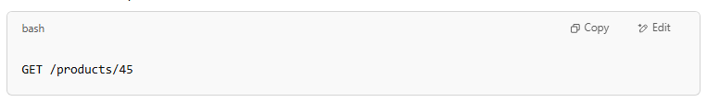
GET /products/45

- /products/45 is the resource being requested.
- It might return product data (e.g., name, price, description) in JSON format.

💡 Summary:
# Source: Chatgpt (GPT-5-Mini) at [1/16/2026]
- A resource is what the client wants.
- It can be content (HTML, image, video), data (like user info), or functionality (like search or login).

